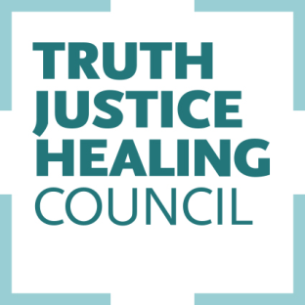
UPDATE 24
Royal Commission St Ann’s Special School Adelaide

20 March 2014

The Royal Commission’s hearing in the case of St Ann’s Special School continued in Adelaide today.

The case of John Ellis is being heard concurrently in Sydney this week.

The Royal Commission heard evidence from Detective Senior Sergeant Walter Conte of the South Australian Police including the nature of the liaison with the Catholic Education Office and the Professional Standards Office in the Archdiocese of Adelaide during the investigation of Brian Perkins.

His evidence also went to advice from SAPOL as to whether or not parents should be informed about the abuse allegations and whether or not parents should contact the media, given the risk, he said, of a mistrial. The Matter became public around March 2002 which is when Archbishop Wilson sent a letter to all parents whose child had attended St Ann’s between 1986 and 1991.

Conte described the strong and positive relationship between the police and the Archdiocese in working on the St Ann's issues.

Later in the day Alan Dooley, former director of the Catholic Education Office in the Archdiocese of Adelaide gave evidence relating to his role in the Archdiocese and his responsibilities relating to the allegations at St Ann’s. Those responsibilities included planning the response to affected families, assisting with the conduct of inquiries by the Catholic Education Office into the circumstances surrounding the allegations made against Perkins 1986-91, establishing a formal point of contact for affected families and communicating with relevant bodies, including the Archdiocese, the Professional Standards Office and the South Australian Police.

Mr Dooley’s statement details how various parties were informed about the allegations, contact with families, the St Ann’s Taskforce (set up to manage the response to the incidents at the school), investigations into how the matter was handled at the time, and payments to former students who were affected.

Mr Dooley said the abuse which occurred at St Ann’s was shocking and appalling and the immediate handling of it in 1991 was unacceptable.

The hearing continues.

For more information on the Truth Justice and Healing Council go to: www.tjhcouncil.org.au
For information on the Royal Commission go to: http://www.childabuseroyalcommission.gov.au/

Contact: Michael Salmon 0417 495 018

